**Final Project**

**Group Members:**

**1] Meet Brijeshkumar Soni**

**2] Parth Dharmendrakumar Shah**

**Step-1]**

**Step-2]**

* **Initialize database**

* **GetAllMovie from Database**

* **GetMovie from specific id:**

* **AddMovie**

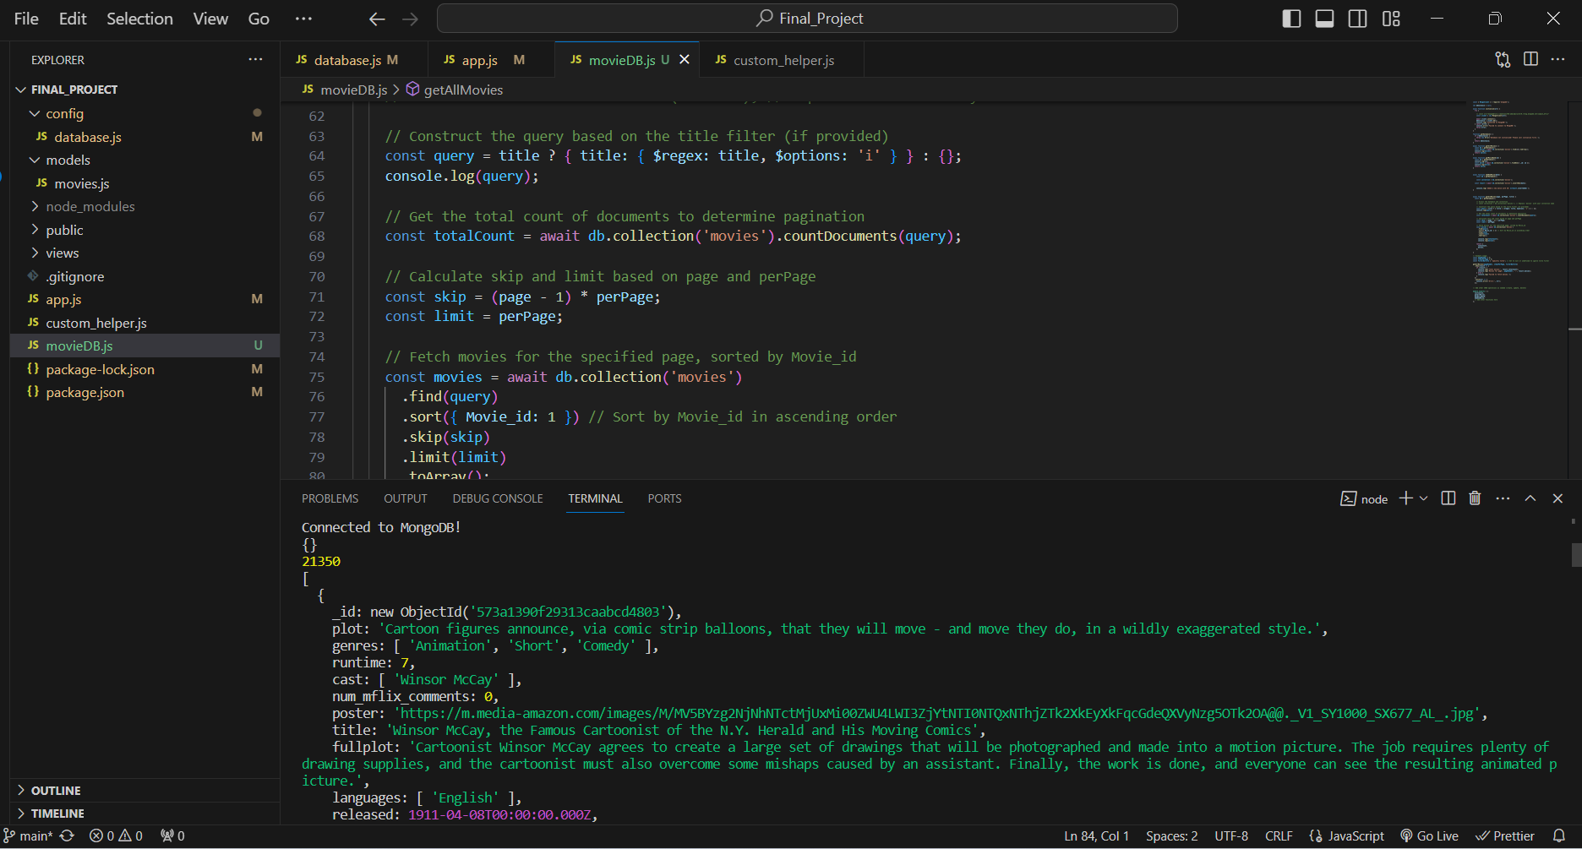

**Specific page movie**

**Update the movie**

**Delete Movie**

**GET/api/moives/id**

**POST /api/Movies**

**GET api/Movies**

**PUT/api/Movies/id -Update movie from id**

**Step-4]**

